HEBDEN BRIDGE TO MYTHOLMROYD ON THE CANAL TOWPATH
Distance and time - 1½ miles, allow about an hour
Things to watch out for – Canada geese, Canal interpretation board
Starting point - The walking board in the St pol car park in the centre of town.
Ending point – The walking board on the side of the Dusty Miller
DIRECTIONS
- Leaving the car park, turn right towards the traffic lights, cross the main road and then straight- ahead down Holme Street, passing the Trades Club to the bridge over the canal.

- Cross the bridge and turn left, after a few metres when you reach the park gates, keep left along the canal towpath.

- After 500 metres you come to a tunnel and the towpath slopes up to the main road.

- Cross the main road using the traffic island (do take care, traffic can be quite speedy and the visibility is not great), turn right and almost immediately pick up the towpath again.

- At the next lock there is a great interpretation board which explains the canal and the history of industry in Mytholmroyd.  There’s also a handy seat to watch the ducks and geese who often nest on this stretch | 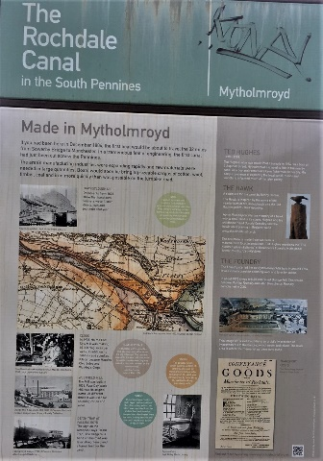

- The towpath now runs behind the busy main road – a much nicer way to walk into the town.

- You pass some flats, then the health centre car park and shortly after come to White lee bridge where you climb some steps to join the road to Midgley.

- Turn right here down to the main road and turn right again to the centre of the town.

