HEBDEN BRIDGE TO MYTHOLMROYD - THERE AND BACK – THE CROW NEST WALK
Calder Holmes park - Crow Nest - Calder Brook - Caldene Avenue
Distance and time - 1½ miles, allow about an hour
Things to watch out for – Crow Nest House, some lovely mixed woodland, the late 18th century Hawks Clough Bridge and farm and some fine railings
Starting point - The board at the Dusty Miller in the centre of town.

- Leaving the car park, turn right towards the traffic lights, cross the main road and then straight- ahead down Holme Street, passing the Trades Club to the bridge over the canal.

- Cross the bridge and turn left, after a few metres go straight ahead through the park gates. Pass the park building and then follow the path around the right-hand edge of the park.

- Exit the park up a slope and turn right when you meet the road by a car park. This takes you into the station area.

- Pass in front of the station drop down the slope and turn right on the rough track under the railway bridge.

- Bear left along the track which follows a wooden fence. Pass Crow Nest house and cottage, on to a lovely wide path through woodland, following the railway line on your left.  - After 300 metres the path emerges onto a tarmac lane where you turn left over the bridge called Carr Lane and descend to a junction. | 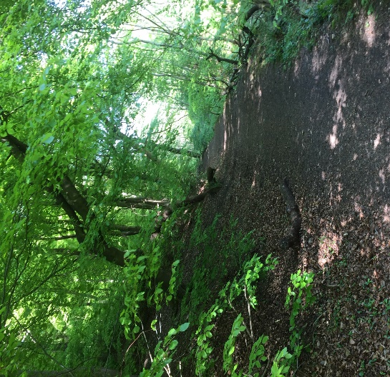
At the junction you have two other options:
You can turn right up a narrow footpath on your right and follow the Stubb walk or
You can cross the bridge, then over the main road to the canal towpath or
To carry on the Crow Nest walk….
- Bear right on a rough tarmac road, passing an old terrace of houses called Calder Brook together with several industrial buildings.

- At the end of the industrial buildings keep straight ahead following the metal fence.

- Where the track forks take the left fork through an old narrow stone gap stile and along the paved path.  On your right is the 18th century Hawks Clough Farm and on your left is Hawks Clough Bridge from around the same period (worth a short detour).  - After the farm, you turn right up a tarmac road to reach Caldene Avenue where you turn left. | 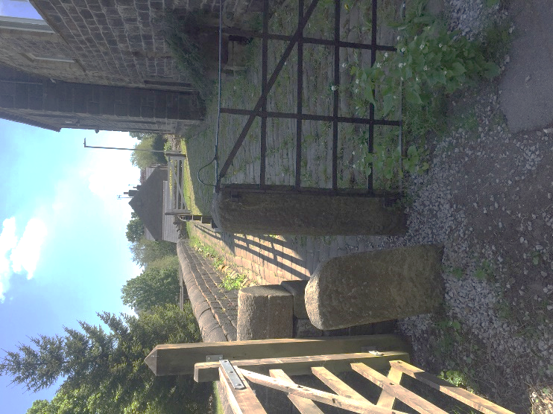

- Caldene Avenue represents the major expansion of the town of Mytholmroyd with houses from the early 20th century to the present day. Watch out for a fabulous set of railings around a house on your left.

- Follow Caldene Avenue until the very end where on your right you pass a Mytholmroyd Walkers Action walking board and the entrance to Mytholmroyd Community Centre.

- The road bears left to join the main Hebden Bridge to Mytholmroyd road where you turn right and you will see the Dusty Miller opposite and another Mytholmroyd Walkers Action walking board where this walk ends.

