HEBDEN BRIDGE TO MYTHOLMROYD THERE AND BACK - THE STUBB WALK
Calder Holmes Park – national cycle path – Stubb pond – Stubb hamlet – Caldene Avenue
Distance and time - 1½ miles, allow about an hour
Things to watch out for - Herons
Starting point - The board in the car park in the centre of town.
DIRECTIONS
- Cross over the main road at the traffic lights turn left and then a few metres further on, by the bus stops turn right through the memorial gardens over the canal

- Turn left down the steps and go straight ahead following the left-hand edge of Calder Holmes park which runs alongside the canal.

- At the end of the park, keep ahead to exit and cross Station Road to go down the rough tarmac road called Mayroyd Lane.

- The tarmac road deteriorates, you go past a stone yard on your right and then you cross a bridge over the River Calder. If you look to your right you will see a long weir over the river and there is often a heron to be seen.

- A few metres further on, just before the railway tunnel, turn left along the tarmac national cycle path which you follow for 600 metres. The path shortly becomes wooded and follows the river.

- When you emerge from the trees into an open area, just keep straight ahead. The cycle path becomes a road and you arrive at a crossroads where are you are now halfway.  - If you look up to your right you will see a small footpath going uphill behind the house. The path levels out then descends, emerging onto a track. | 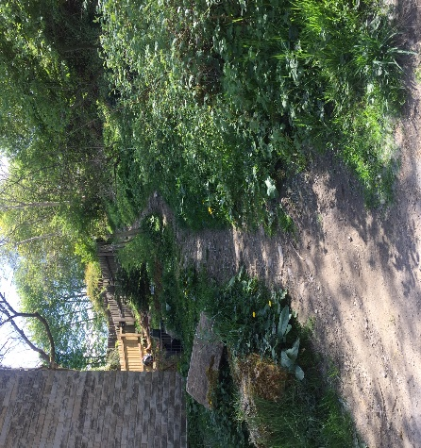  The narrow path on your right

- Turn right under the railway and follow the track to your left.
You will pass Stubb Conservation Pond on your right. The gate is not usually secured and the dedicated owner welcomes people to come and rest awhile in this delightful quiet haven for wildlife (secure the gate as you leave).
As a child, Ted Hughes used to swim in the pond, but it is certainly not advisable now!

- The track has remains of granite setts and emerges at a junction where you go straight ahead in front of a terrace of houses.

- Shortly after, you will see the 17th century house called Great Stubb on your left. At the junction turn left and then to the right of a garage, you take a narrow path in between two hedges  - Follow this lovely paved path down to the bottom (watch out as paving stones can be a bit slippery after rain). | 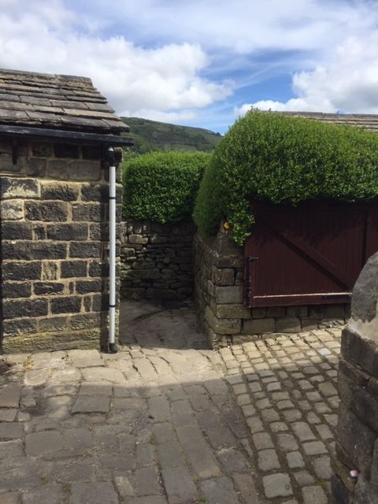  The entrance to the narrow path

- Go down the steps, cross the railway line, go straight ahead on a hedge-lined path. You come out onto a tarmac road where you turn right. At the bottom turn right onto a road called Caldene Avenue.

Caldene Avenue represents the major expansion of Mytholmroyd with houses from the early 20th century to the present day. Watch out for a fabulous set of railings around a house on your right.

- Follow Caldene Avenue until the very end where on your right you pass a Mytholmroyd Walkers Action walking board and the entrance to Mytholmroyd Community Centre.

- The road bears left to join the main Hebden Bridge to Mytholmroyd road where you will see the Dusty Miller opposite and another Mytholmroyd Walkers Action walking board where this walk ends.

