HEBDEN BRIDGE TO MYTHOLMROYD - THERE AND BACK - THE RAW LANE WALK
Nutclough – Burlees Lane – Raw Lane – Foster Clough - Dark Lane
Distance and time - 2 miles, allow about an hour and a half
Things to watch out for – the lovely Nutclough valley, panoramic views of the Calder Valley, maybe llamas
Starting point - The board in the St Pol car park in the centre of town.
The first section is quite a long but rewarding climb, but if you want to avoid this, get the 595 bus to Doddnaze estate and walk up the road to join the walk at point 11

- Leaving the car park turn left down the pedestrianised Bridgegate.

- Pass the fustian knife in Saint Georges Square, head past the mill and the White Lion pub where you turn left up the main Keighley Road

- Walk for about 300 metres to a set of traffic lights where you cross the road. Head up hill for 30 metres and turn right up a track before the former Nutclough Tavern.
- At the gate keep left, after a 50-metre gentle climb, at a stone wall turn left up a short flight of stone steps.
- You will now see the Nutclough Mill pond on your right with some benches to stop and sit or you can wander round the paths. You may see some unusual birds and if you’ve got children, they will want to play in the water but do take care as there are some deep spots.
- To continue the walk, take the stone steps up to a footpath (marked link path) which rises up on the left-hand side above the pond.  - Where it levels out go on to the 18th century Hurst Bridge for a lovely view down Nutclough valley – almost a gorge | 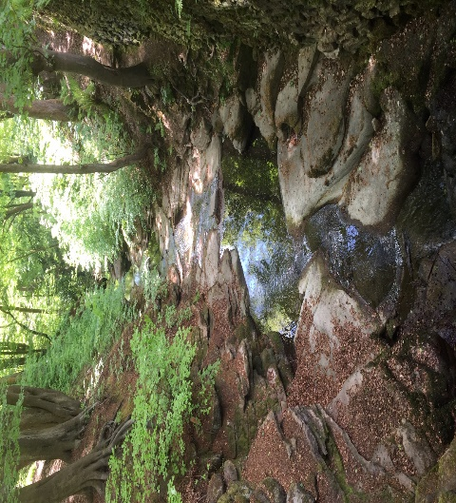

- Cross over the bridge and go along the wide path and very shortly after take the small path going off to the left uphill. The path comes out on a tarmac road.

- Cross the road and go up the walled lane opposite right to the very top ignoring the turning off to the right.

- At the top go through a gate and immediately turn right on the wide stone track which comes out on the tarmac road at the end.

- Cross the road and go across to a partly tarmac lane which is called Burlees Lane. You now stay on this lane for 250 metres until some houses on your left called Burlees Cottages.  - Immediately after the houses, turn left up a path which runs diagonally up the field. The path bears right following some holly trees and crosses a stile. | 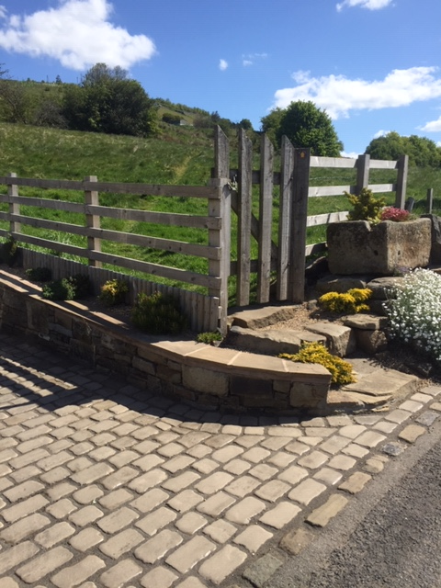

- The path emerges on to a wide path and you turn left for 50 metres. At the top you turn right on to the wide track called Raw lane which you follow for about 600 metres.

- At the junction with a hairpin bend in a road, keep ahead slightly downhill. Arriving at a 4-way junction take the left fork by a tree stump seat (the tarmac Raw Lane heads down to your right).  - The rough paved path goes uphill and forks right to a derelict house. After the house, follow the path ahead through a field. | The tree stump seat

- The path joins a track to Old Castle Farm. After the farm, go through a metal gate and keep straight ahead across the field. After a small stream crossing go ahead into a narrow path through trees to emerge on to a bend in a tarmac road.

- Go straight ahead behind two houses called Heyhead Farm. The path goes through a bit of garden and then through a fenced field. At the end go through a gate down to a bridge over the delightful Foster Clough.

- The path slopes up to a field where you go straight ahead to a junction of paths and go through a metal gate.

- You are now in a lovely old walled lane and after 200 metres at a junction turn right downhill on another walled path called Dark lane.

- Follow this to the bottom, passing a cluster of houses, emerging on to a concrete track which emerges on to a tarmac road.

- Turn right down this road for 500 metres, passing Calder High School on your left.

- At the bottom, turn right along the main road and in a few steps, you will be in the centre of the town.

