HEBDEN BRIDGE TO MYTHOLMROYD THERE AND BACK - THE WOOD TOP WALK
Bit of a climb at first, but then a level route into Mytholmroyd.
Distance and time - 1½ miles, allow about an hour
Things to watch out for – great views of the valley, some fine old farmhouses
Starting point - The board in the St Pol car park in the centre of town.

- Leaving the car park, turn right towards the traffic lights, cross the main road and then straight- ahead down Holme Street past the post office to the bridge over the canal

- Cross the bridge and turn right along the canal for a short distance, passing over an aqueduct and an interesting information board about the canal

- At the end, go up a flight of paved steps, turn right and coming out on a road.

- Turn left along the road, over the railway bridge and just before the bus stop, cross the road and follow a rough tarmac track uphill

- At the bungalow, take the waymarked footpath going off to the left, running above some houses. At a crossroads of paths, take the path straight ahead uphill through some woods, passing a disused quarry and follow this to reach the 17th century settlement of Wood Top. In Winter you get great views of the opposite hillside and if you look back you can see Hebden Bridge through the trees

- Arriving at a junction, turn right along a track alongside Wood Top Farm (see photo opposite). Wood Top had a mill and the big wall on your right is the retaining wall of a mill dam that still exists  - Passing the post box, go straight ahead on a concrete road and after 50 m turn left along the track called Wood Hey Lane, which you follow for half a kilometre | 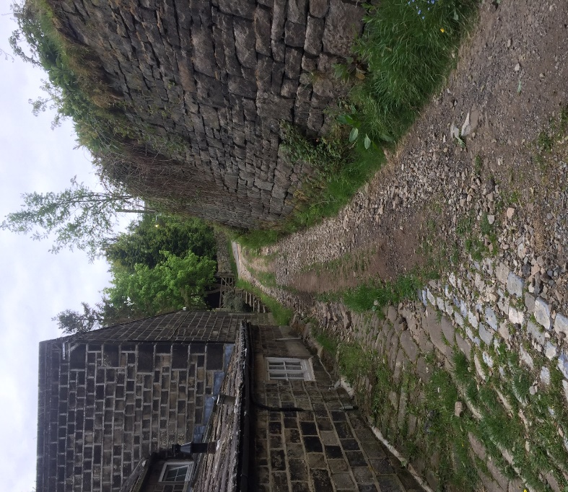

Things to watch out for on your way
- You pass a pair of houses called Shroggs and Bodds Biggin dated 1697.
- Shortly after if you look to your left you will see a rather surreal waterwheel
- As you cross the stream watch out for the gnome house on your right, this is part of Mytholmroyd Walkers Action children’s walks - details available on their website
- Further on, looking up to your right you will see Park Fold a fine example of an early 17th century yeoman’s house and barn
Just after Park Cottage there is a footpath going down to the left and that will take you to the old hamlet called Stubb and if you want to shorten your walk, it is a short hop from there back to Hebden Bridge

- To continue our walk, the track now becomes tarmac called Nest Lane and you follow this for a further ¾ km to a junction of roads

- At the junction bear left along Thrush Hill Road, just before the very narrow railway tunnel, cross the road and go up a set of stone steps (see photo opp.)  - Follow the tarmac path down a slope to the end of the sheltered housing complex  - At the end turn left along the tarmac road and then turn right up a ramp to cross the river on the metal foot bridge which was put in after the devastating 2015 floods | 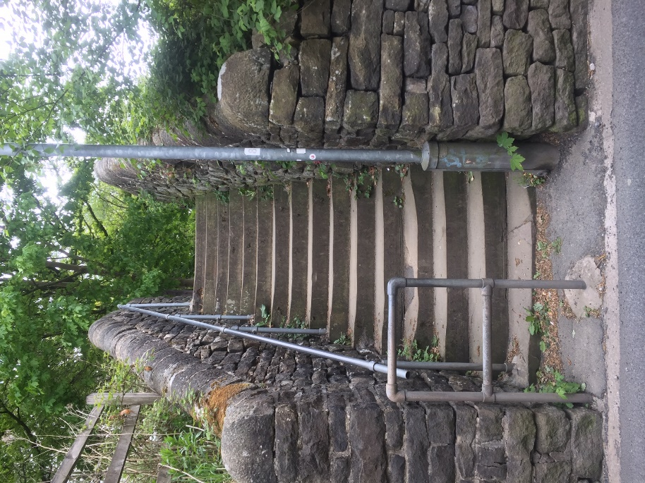

- At the Shoulder of Mutton pub, turn left along the main road, under the railway line, over the river and you will reach the centre of Mytholmroyd

- The 18th century Dusty Miller, which is the end of the walk is over the main road to your left

