MYTHOLMROYD TO HEBDEN BRIDGE THERE AND BACK - THE CROW NEST WALK
Caldene Avenue – Calder Brook – Crow Nest – Calder Holmes park
Distance and time - 1½ miles, allow about an hour
Things to watch out for – some fine modern railings, the late 18th century Hawks Clough Bridge and farm some lovely mixed woodland and Crow Nest House,
Starting point - The board at the Dusty Miller in the centre of town.

DIRECTIONS
- From the Dusty Miller, cross the road, either at the pedestrian crossing or the temporary lights (it’s a moveable situation at the moment!).
- Just after Sainsbury’s, cross the bridge on your left to join Caldene Avenue. Carry on past the entrance to Mytholmroyd Community Centre and another Mytholmroyd Walkers Action board.
- You now walk down nearly to the end of Caldene Avenue (watch out for the fantastic railings on a house on the left). Caldene Avenue represents the major expansion of the town of Mytholmroyd with houses from the early 20th century to the present day.
- When you see Linden Road on your left, just before the turning, turn right on a narrow lane that leads to the 18th century Hawks Clough Bridge (on the right of the photo and worth a short detour).  - You take a path running along Hawks Clough farm house built around the same time. Go through a stone gap stile. | 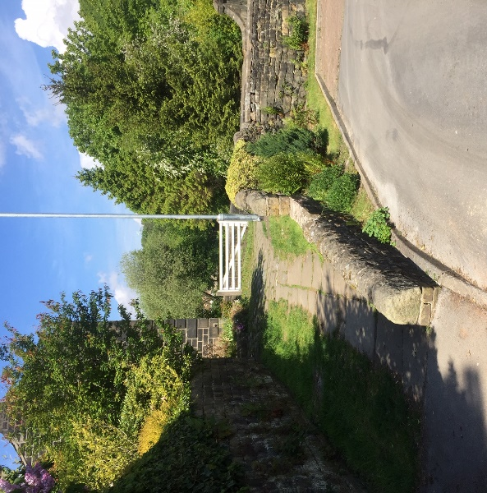
- You join a track which follows a metal fence on your right. The track emerges into a rough tarmac road passing several industrial buildings and an old terrace of houses called Calder Brook. The tarmac road emerges at a junction.
At the junction you have 2 other options:
You can turn sharp left up a narrow footpath and follow the Stubb walk back to Mytholmroyd or
You can go straight ahead following the cycle path to Hebden Bridge or
- To carry on the Crow Nest walk, you take the road going up to the left leading to a railway bridge.

- Immediately after the bridge take the path going off to the right.  The wide path goes through some lovely woodland, following the railway line. You pass the imposing Crow Nest House.  The path then follows a wooden fence and emerges at the back of Hebden Bridge railway station. | 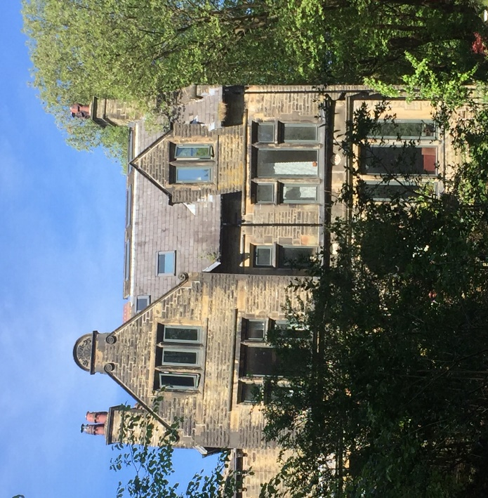

- Bear right down a rough concrete track and go under the railway tunnel. You cross the cycle path back to Mytholmroyd and then cross the bridge over the River Calder (watch out for a heron on the weir). Carry on through the stone yard at Mayroyd until you reach a tarmac road which is the road to the station.
- Go straight ahead into Calder Holmes Park following the path on the right-hand edge of the park alongside the canal.
- Just after the outdoor gym on your left, go up a set of steps on your right, cross the canal bridge and go through the memorial gardens, to emerge on to the main road. If you look to your left you will see the lights to cross to St Pol car park, the end of this walk.

