MYTHOLMROYD TO HEBDEN BRIDGE – THERE AND BACK - THE STUBB WALK
Caldene Avenue – Stubb – National cycle path - Mayroyd – Calder Holmes Park
Distance and time - 1½ miles, allow about an hour
Things to watch out for – Stubb Conservation Pond, old hamlet of Stubb, Herons
Starting point - The board at the Dusty Miller in the centre of town.

DIRECTIONS
- From the Dusty Miller, cross the road, either at the pedestrian crossing or the temporary lights (it’s a moveable situation at the moment!).

- Just after Sainsbury’s, cross the bridge on your left to Caldene Avenue. Carry on past the entrance to the Community Centre and a second Walkers Action board.
- You now walk down nearly to the end of Caldene Avenue (Watch out for the fantastic railings on a house on the left).
Caldene Avenue represents the major expansion of Mytholmroyd with houses from the early 20th century to the present day. Watch out for a fabulous set of railings around a house on your right.
- When you come to the Caldene Croft sign, turn left up a tarmac road. At the top of the slope bear left on a paved footpath running between two high hedges (can be slippery after rain).  You then cross a railway bridge and continue ahead on a paved path between two hedges. | 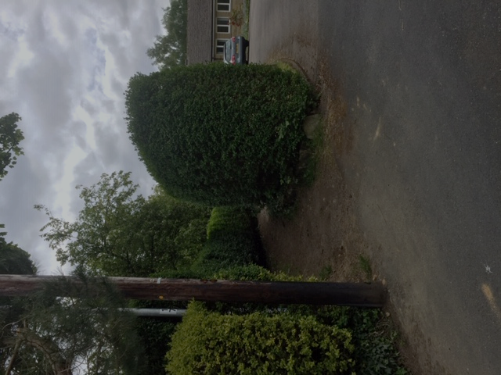  The start of the paved footpath

- You come out into a paved yard in between a cluster of old houses with the early 17th century house Great Stubb on your right. Go straight ahead on the short length of tarmac road and at the junction turn right on a paved track past the front of a house.
- Just pass the house go straight ahead on the rough tree lined track with one half still having the old setts.
You will pass Stubb Conservation Pond on your left. The gate is not usually secured and the dedicated owner welcomes people to come and rest awhile in this delightful quiet haven for wildlife (secure the gate as you leave).
As a child, Ted Hughes used to swim in the pond, but it is certainly not advisable now!
- The track turns right under railway and you immediately turn left up a narrow path. Wherever the path forks, keep right. The path emerges at a junction of tracks
- Take the tarmac road bearing slightly left (signed as part of the National cycle path network) and follow this for 600 metres.  It is initially a wide road, then becomes a path going along side of the river with the last section in woodland. | 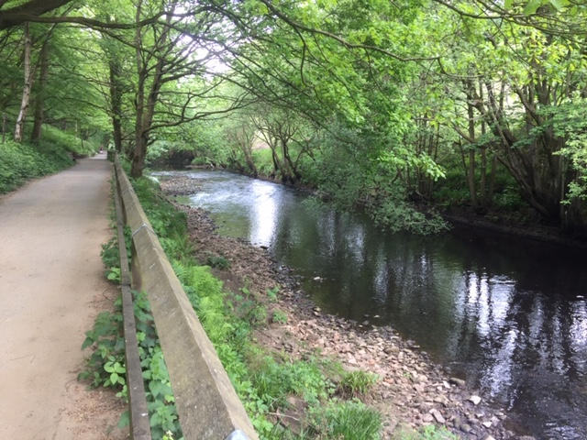

- At the junction with three concrete pillars ahead of you, turn right on a rough track over the bridge. If you look to your left you will see a long weir over the river and there is often a heron to be seen. Carry on through the stone yard at Mayroyd until you reach a tarmac road which is the road to the station.
- Go straight ahead into a park following the tarmac path on the right-hand edge of the park alongside the canal.
- The path leaves the park and you turn right over a canal bridge.
- Drop down and turn right into Holme Street. Pass the Post Office to the traffic lights. Cross over at the lights and you will reach the St Pol car park and the Walkers Action walking board.

