MYTHOLMROYD TO HEBDEN BRIDGE – THERE AND BACK – THE WOOD TOP WALK
A very gentle uphill walk along quiet lanes and tracks, then a lovely woodland descent into Hebden Bridge.
Distance and time - 1½ miles, allow about an hour
Things to watch out for – great views of the valley, some fine old farmhouses
Starting point - The board at the Dusty Miller in the centre of town.

- Leaving the car park, turn left towards the pedestrian crossing, cross the main road and then cross the bridge over the river. Continue ahead and just after the railway bridge, just before the Shoulder of Mutton pub, go over a foot bridge on your right
- Turn left off the ramp for 50 metres and on your right take a small tarmac path (see photo opp.) which takes you through the sheltered house estate  - The path crosses a road and at the end you go up a slope and down a set of stone steps where you will see the narrow Thrush Hill tunnel on your right  - You turn left here and after 150 metres arrive at a junction where you bear right on to Nest Lane which follows the edge of Nest Estate | 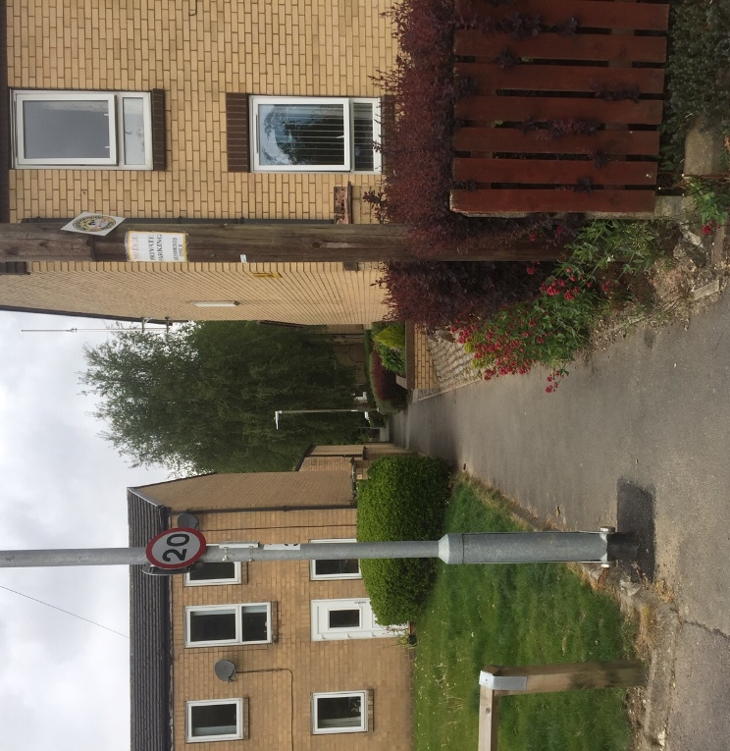
- After about 400 metres, at Roger Gate, keep left on the tarmac road which is now called Park Lane. After 250 metres, at a terrace of houses called Little Park, keep right at the fork where the tarmac stops and becomes a wide track. You follow this for half a kilometre
Things to watch out for on your way

- At the fork look up to your left to see Park Fold - a fine example of an early 17th century yeoman’s house and barn
- At the stream watch out for a gnome house on your left, this is on a Mytholmroyd Walkers Action children’s walk - details on their website
- You pass a pair of houses called Shroggs and Bodds Biggin dated 1697.
- At the end of Park Lane, you arrive at a junction with the road coming steeply down from Old Chamber – Spencer Lane
- Here you turn right on a concrete road and after 50 metres, where the road bends to the right at a post box, keep ahead to the left of the 17th century settlement of Wood Top (with the high wall of a mill dam on your left). After 20 metres turn left at the junction
- You now follow this track for 500 metres, initially level, then eventually descending through some lovely woodland. You pass a disused quarry and in Winter there are great views of Hebden Bridge in the valley below  - When you arrive at a cross roads (see photo opposite), go straight ahead on a narrower path which runs behind some houses.  - Where it joins a tarmac lane, turn right downhill eventually arriving at a tarmac road called Park View | 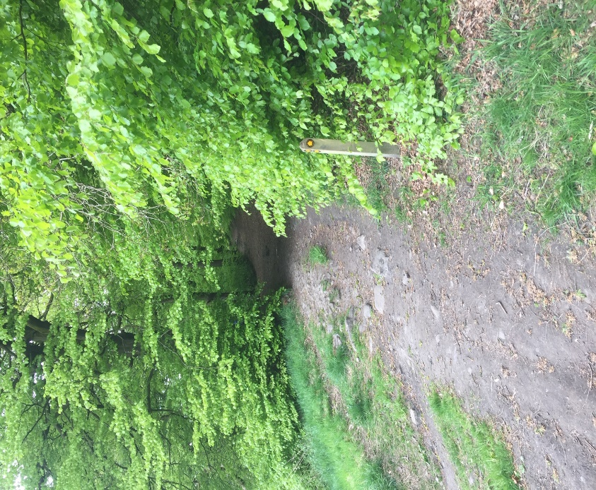

- Turn left here, cross the railway bridge and just before a terrace of houses, take the path going through the wall on the right. Turn right along the path, then left down the concrete steps. Turn right at the bottom to follow the canal, going over an aqueduct and stop to have a look at the canal interpretation board as you pass
- Cross the canal bridge, go down the slope and turn right along the street. Pass the Post Office and at the end, cross the main road at the lights and you will see St Pol car park over to your left

