MYTHOLMROYD TO HEBDEN BRIDGE – THERE AND BACK – THE RAW LANE WALK
Throstle Bower – Raw Lane – Foster Clough - Burlees Lane - Nutclough
Distance and time - 2 miles, allow about an hour and a half
Things to watch out for – panoramic views across the valley, the lovely Nutclough, Foster Clough stream, Llamas
Starting point - The board at the dusty Miller in the centre of town.
To take out a bit of the road climb, you could get the 597 bus from Hebden Bridge to Banksfield estate joining at point 2. It is possible to do this walk with a buggy.

- Leaving the Dusty Miller, head past the war memorial and at the end of the shops turn left on the Midgley road

- Walk up Midgley road for about 600 metres, passing Calder High School on your right

- Just before the road turns to the right, take the rough tarmac drive going off to your left. At the fork, keep straight ahead

- At Throstle Bower farm go through the gate and turn left between the house and the old stables. At the end of the yard you go up an old partly paved path which turns right up hill - it’s a bit of a steep climb so take your time

- Towards the top, the path turns to the left, go straight ahead past the stables and then keep straight ahead on the concrete track which becomes a narrow tarmac road. The road starts of skirting to hillside and then gently climbs up
- You emerge into a junction of lanes around a cluster of houses where are you go straight ahead uphill on a tarmac lane
- At the hairpin bend you go straight ahead on a track. At the first house go straight ahead. The track now has a range of different surfaces.
- After about ½ km watch out for a finger post off to the left which says public footpath  Here you have an alternative more suited for buggies. You can walk right to the end of Raw lane where you meet a road. Here you turn left downhill which if you keep going you will pass Doddnaze estate and Birchcliffe to arrive in the centre of Hebden Bridge | 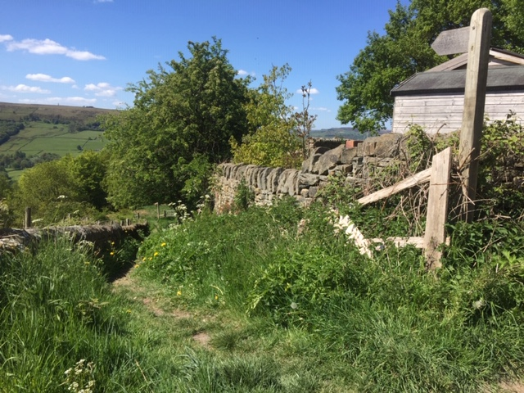  The turning off Raw Lane

- Continuing our walk, go down the path for 50 metres and at a finger post go through a metal gate on the right. Follow the path along the fence line
- Cross the stile and follow a broken-down wall. Just after some Holly trees there is a gap in the wall and you can see the footpath going off diagonally to the left
- The path drops down to the corner of the field by a terrace of houses. Go through the gate and turn right on to Burlees Lane which you walk right to the end
- At the junction cross over the road to a track which you follow for 150 metres where, at a crossroads you turn left down a wide path, going through a metal gate. At the bottom of the path, cross the road on to a narrow path which descends to a wider track where you turn right to Hurst Bridge.
- Coming off the bridge turn left on the path which heads downhill following above the stream. The path descends to the old mill dam where you might want to linger and watch some of the wild life.
- Drop down a set of stone steps and keep ahead on a track which gradually descends to the main road.
- Turn left down the main road and you will shortly see the town centre below you
Repairs needed

- Dark lane needs cutting back
- At the hairpin bend needs a four-way waymark

